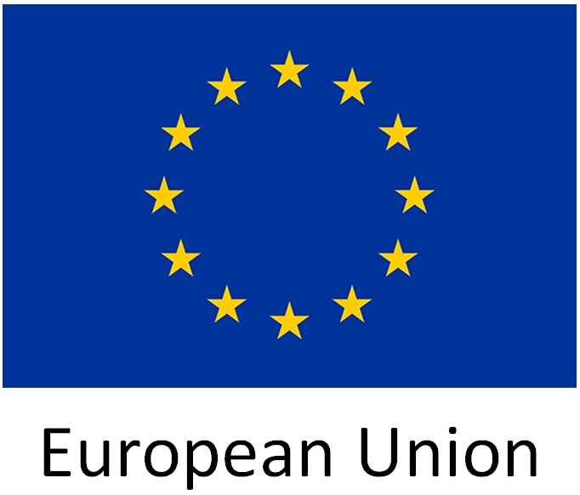 |  | 
O'zbekiston Respublikasi
Sudyalar oliy kengashi
Supreme Judicial Council of Uzbekistan and International Commission of Jurists hold joint seminar on judicial appointments
Today, 8 September, the International Commission of Jurists (ICJ) and the Supreme Judicial Council of the Republic of Uzbekistan (SJC) hold a joint International Seminar on Comparative Approaches to Selection, Appointment and Evaluation of Judges. The event was supported by the European Union (EU) within the Project "International Human Rights Law Training and Exchange to Improve National Justice Systems in Central Asia." The United Nations Office for Drugs and Crime (UNODC) has also co-operated in the event.
The seminar will be opened by Ma’ruf Usmanov, President of the Supreme Judicial Council of the Republic of Uzbekistan. It will address issues related to the institutions and procedures on appointment and selection of judges as well as assessment of judicial performance. International standards and national comparative examples will be discussed, including experiences of Uzbekistan, Austria, Germany, Kazakhstan, the Kyrgyz Republic and Serbia. The European and Central Asian perspectives will allow the participants to identify common challenges and find ways to address them.
“At a time when Uzbekistan is undertaking significant reforms of the judiciary, it is important to ensure that the procedures for selection, appointment and assessment of judicial performance guarantee the independence of the judiciary, which is a foundation for protection of the rule of law and human rights”, Róisín Pillay, Director of the ICJ Europe and CIS Programme said in advance of the seminar. “We are happy to have this opportunity to work with the Uzbekistan judiciary and to contribute to their debate on these issues” she added.
As was highlighted by Radoslaw Darski, Head of Political, Press and Information Section of the EU Delegation in Uzbekistan "The European Union is founded on a strong engagement to promote and protect human rights, democracy and rule of law worldwide. Sustainable peace and stability, long-term development and prosperity cannot exist without respect for human rights and democratic institutions. This commitment underpins all internal and external policies of the European Union."
Speakers at the seminar included senior judges from the ICJ network.
For more information:
International Commission of Jurists (ICJ) www.icj.org  Contact person:  Dina Massanova dina.iskaliyeva@icj.org | EU Delegation in Uzbekistan  Contact person:  Akmal Rustamov  Akmal.RUSTAMOV@eeas.europa.eu | Supreme Judicial Council of Uzbekistan  https://sudyalaroliykengashi.uz  Contact person:  Sherzod Yuldashev  interdep.tm@gmail.com
Attachments: Agenda

